|  |  |
| --- | --- |
| Team ID | PNT2022TMID25354 |
| Project Name | Car Resale Value Prediction |

Project Folder Structure

Let us introduce you to the main project folder downloaded by you in prerequisites.

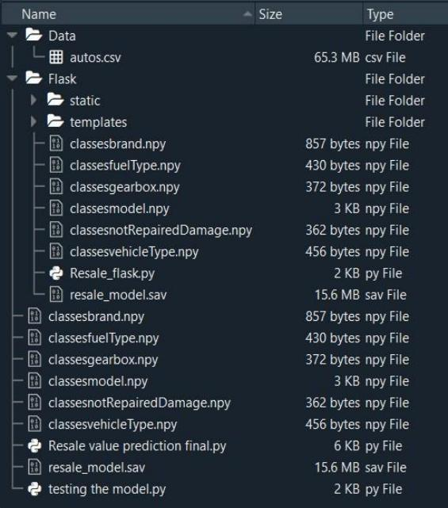

• “Resale value prediction final.py” has all the mastery model building architecture, that Collects Data, Import necessary packages, Pre-process images, and passes on to Network Model and Saves Model Weights into **“resale** **model.sav”** **.**

• “Resale flask.py” takes weights and Inputs from “User Interface” to Predict output.

• The .npy format is the standard binary file format in NumPy for persisting a single arbitrary NumPy array on disk. The format stores all of the shape and dtype information are necessary to recons truct the array correctly even on another machine with a different architecture.